2021

Planning & Management

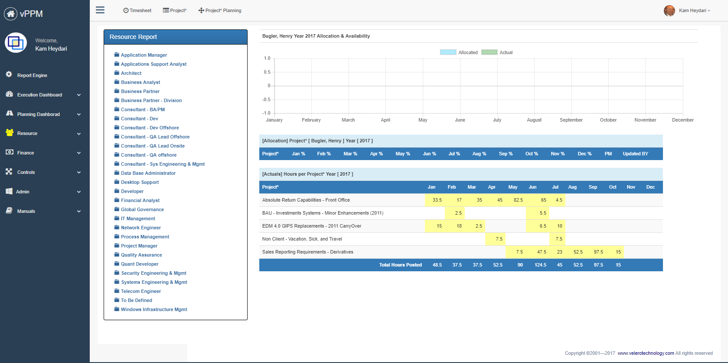

**Student Name:**

Saloni Sankhe

Saneel Tare

Shemal Shah

Sneha Swaroop

**Assignment Name:**

Target – group 8

Contents

2. Company Strategy & Scorecard 2

2.1. Company Background 2

2.2. SWOT Analysis 2

2.3. Scorecard 3

2.4. Reference information 4

3. Project Definition 4

3.1. Project Business Case 4

3.1.1. Project overview 4

3.1.2. Business issues/opportunities 4

3.1.3. Project Business Goals 5

3.2. Primary Project Objectives 5

3.3. Project Benefits 5

3.4. Primary Project Deliverables 6

3.4.1. Project milestones 6

3.4.2. Project Interdependencies and Inputs 6

3.5. Project Conditions 7

3.5.1. Assumptions 7

3.5.2. Risks and Issues 7

3.5.3. Project Constrains 7

3.6. Project Critical Success Factors (Key Performance Indicators) 8

3.7. Scope 8

3.8. Strategy Matrix 9

3.9. Work Breakdown Structure 10

3.10. Resource and Cost Estimate 10

3.10.1. Cost 10

3.10.2. Resource Needed 11

3.11. Roles & Responsibility Matrix 12

3.12. Project Structure 13

3.13. Resource requirement Matrix 14

3.14. Project Schedule 15

# Company Strategy & Scorecard

## Company Background

* Target is a general merchandise retailer with stores in all 50 U.S. states and the District of Columbia.
* Target Corporation is an American [big box](https://en.wikipedia.org/wiki/Big-box_store) [department store](https://en.wikipedia.org/wiki/Department_store) chain headquartered in Minneapolis, Minnesota.
* Target Corporation is the fourth largest retailer in the United States, operating 1,556 stores in 47 states
* As of 2021, Target operates 1,926 stores throughout the United States, and is ranked number 37 on the 2020 Fortune [500](https://en.wikipedia.org/wiki/Fortune_500) list of the largest U.S. corporations by total revenue.

## SWOT Analysis

|  |  |
| --- | --- |
| Strength   * High quality and Innovative products attract customers * Strong Financial Growth * Partnership with multiple corporations * Budget friendly | Weakness   * Customer Data Security * The ECommerce department significantly lags as compared to big competitors * Lack of product line diversity |
| Opportunity   * Little presence in the International Market * Increase online sales * Increase customer service * Attract all age groups | Treats   * Rising Costs * **Low Barrier to Entry** * **Stiff Competition** with Walmart, amazon * **Changing Customer Preferences** |

## Scorecard

## Reference information

* <https://corporate.target.com/press/releases/2021/03/Target-Builds-on-Momentum-Announces-2021-Strategic>
* <https://investors.target.com/static-files/717a6df4-172c-484e-afbd-611131a7ce7b>

# Project Definition

Project Name: Increase Online Sales through app and membership programs

## Project Business Case

### Project overview

Target is a general merchandise retailer with stores in all 50 U.S. states and the District of Columbia. 75% of the U.S. population lives within 10 miles of a Target store. Where Target focuses on helping all families discover the joy of everyday life, operating 1,926 stores throughout the United States. The problem they are facing is challenges to increase online sales. 95% of the sales are generated through in-store. Target should bridge the gap between the in-store and online sales to overall increase the revenue. Target should also make efforts to bring down the median age from 40 and cater for a young crowd.

### Business opportunities

* Bring a referral program to get new customers
* Introduce a new and cheap membership
* Start a 2-hour delivery option
* Reduce the median age to 25
* Introduce a student membership account

### Project Business Goals

|  |  |
| --- | --- |
| ID | Objective/Goal |
| O1 | Reduce the gap between sales through app and in stores |
| O2 | Have 50 million members buying through the app |
| O3 | Successfully deliver 1 million shipments under their “2-hour delivery option” |

## Primary Project Objectives

* Increase sales through app
* Reduce Median Age
* More students in membership
* Increase total no of customers

## Project Benefits

* Large customer base
* Generate more revenue
* Increased customer convenience
* Increase user traffic on the app
* Encourage impulse buy
* A strong online presence gives Target a proof of concept

## Primary Project Deliverables

### Project milestones

|  |
| --- |
| 1.Market Research |
| * How many would apply for a membership if it would have been cheaper * How many would want a 2hour delivery program * How User Friendly the app is? |
| 2.Marketing/ advertisement |
| * Referral program * Student offers during start of a semester * Make influencers exclusive to target app (larger audience) |
| 3.Sales |
| * 20 million users on the app within 6 months * 8 million students out of 20 million in the student membership program * Sales through app should be 25% of total revenue |

### Project Interdependencies and Inputs

|  |
| --- |
| Project Interdependencies and Inputs |
| * Create algorithm to increase impulse buy * A efficient supply chain * Revamp the Ui of the app |

## Project Conditions

Includes your project assumptions break them down by (resources, delivery, budget, scope, schedule, methodology, technology, and architecture & design)

### Assumptions

[Identify all known assumptions that apply to this project.]

| **ID** | **Item** |
| --- | --- |
| A1 | This project works with internal flights Because Internet access is available on internal flights so that the customer can track the bag |
| A2 |  |
| A3 |  |
| A4 |  |

### Risks and Issues

Identify risks and issues in the following forms.

|  |  |  |  |
| --- | --- | --- | --- |
| **Risk** | **Prob** | **Impact** | **Mitigation** |
|  |  |  |  |
|  |  |  |  |
|  |  |  |  |
|  |  |  |  |
|  |  |  |  |

### Project Constrains

[Replace this text with an outline of all known constraints that apply to this project.]

## Project Critical Success Factors (Key Performance Indicators)

[Replace this text with an outline of all known critical success indicators that apply to this project.]

## Scope

Define what is in- and out- of scope for your project.

#### In scope

**Sample**: The In-Scope functions will be assessed from both an interim and future state perspective, incorporating the specific organization complexities relative to global lines of business, asset classes, reporting, and operational processes. The following capabilities are agreed to be in-scope for the data assessment and target state design:

| **ID** | **Type** | **Definition** |
| --- | --- | --- |
| S1 | Customer | Definition of what is in the project scope as far as customer is concerned |
| S2 | Airline |  |
| S3 | Inventory |  |

#### Out of Scope

**Sample**: The following areas are agreed to be out of scope for the Data Assessment:

| **ID** | **Item** |
| --- | --- |
| OS1 | Organization changes … |
| OS2 |  |
| OS3 |  |

## Strategy Matrix

Define complete strategic matrix for your project using strategic matrix table – Identify 4 strategies for the organization – See lecture material and PMI material.

|  |  |  |  |  |
| --- | --- | --- | --- | --- |
| Project Objectives | Strategies | | | |
| **Strategy** | **Strategy** | **Strategy** | **Strategy** |
|  |  |  |  |  |
|  |  |  |  |  |
|  |  |  |  |  |
|  |  |  |  |  |
|  |  |  |  |  |
|  |  |  |  |  |
|  |  |  |  |  |

## Work Breakdown Structure

Define your work breakdown structure for your project – See Lecture material

## Resource and Cost Estimate

Using the following format define your resource (Excluding FTE Cost) cost estimates.

### Cost

|  |  |  |  |
| --- | --- | --- | --- |
| Cost Description | Schedule (year) | Amount | Note |
|  |  |  |  |
|  |  |  |  |
|  |  |  |  |
|  |  |  |  |
|  |  |  |  |
|  |  |  |  |

### Resource Needed

|  |  |
| --- | --- |
| Resource Type | Note |
|  |  |
|  |  |
|  |  |
|  |  |
|  |  |
|  |  |

## Roles & Responsibility Matrix

Define roles and responsibilities using RACI model for all participating resources.

|  |  |  |  |  |  |  |  |  |  |
| --- | --- | --- | --- | --- | --- | --- | --- | --- | --- |
| **Project Team**  **|**  **Area of Responsibilities** | |  |  |  |  |  |  |  |  |
|  |  |  |  |  |  |  |  |  |  |
|  |  |  |  |  |  |  |  |  |  |
|  |  |  |  |  |  |  |  |  |  |
|  |  |  |  |  |  |  |  |  |  |
|  |  |  |  |  |  |  |  |  |  |
|  |  |  |  |  |  |  |  |  |  |
|  |  |  |  |  |  |  |  |  |  |
|  |  |  |  |  |  |  |  |  |  |
|  |  |  |  |  |  |  |  |  |  |
|  |  |  |  |  |  |  |  |  |  |
|  |  |  |  |  |  |  |  |  |  |
|  |  |  |  |  |  |  |  |  |  |
|  |  |  |  |  |  |  |  |  |  |
|  |  |  |  |  |  |  |  |  |  |
|  |  | R | A | C | I |  |  |  |  |
|  |  |  |  |  |  |  |  |  |  |
| **Responsible** | | People or stakeholders who are the "doers" of the work. They must complete the task or objective or make the decision. Several people can be jointly *Responsible*. | | | | | | | |
| **Accountable** | | Person or stakeholder who is the "owner" of the work. He or she must sign off or approve when the task, objective or decision is complete. This person must make sure that responsibilities are assigned in the matrix for all related activities. ***Success requires that there is only one person Accountable.*** | | | | | | | |
| **Consulted** | | People or stakeholders who need to give input before the work can be done and signed-off on. These people are "in the loop" and active participants. | | | | | | | |
| **Informed** | | People or stakeholders who need to be kept "in the picture." They need updates on progress or decisions, but do not need to be formally consulted, nor do they contribute directly to the task or decision. | | | | | | | |

## Project Structure

Define your project structure considering information provided in the project mandate.

## Resource requirement Matrix

Define resource requirement matrix per work pages using the format that was provided to you in the class and for your group assignment.

|  |  |  |  |  |  |  |  |  |  |  |  |  |
| --- | --- | --- | --- | --- | --- | --- | --- | --- | --- | --- | --- | --- |
| Resource/Month | 1 | 2 | 3 | 4 | 5 | 6 | 7 | 8 | 9 | 10 | 11 | 12 |
|  |  |  |  |  |  |  |  |  |  |  |  |  |
|  |  |  |  |  |  |  |  |  |  |  |  |  |
|  |  |  |  |  |  |  |  |  |  |  |  |  |
|  |  |  |  |  |  |  |  |  |  |  |  |  |
|  |  |  |  |  |  |  |  |  |  |  |  |  |
|  |  |  |  |  |  |  |  |  |  |  |  |  |
|  |  |  |  |  |  |  |  |  |  |  |  |  |

Using Velero product include the estimated cost (Screen shot)

## Project Schedule

Using the following format to define complete project schedule using PMI (initiation, Planning, Execution, Monitoring and Control and Closure.) Start date 1/1/2022. Make your project schedule as realistic as possible please. Identify all the dependencies, using task ID.

Input the information into Velero and generate the Gantt chart. Include the Gantt chat screen shot.

|  |  |  |  |  |  |
| --- | --- | --- | --- | --- | --- |
| Task ID | PMI | Tasks/Milestone | Start | End | Dependency |
| 1 | Initiation |  | 1/1/2020 |  |  |
|  |  |  |  |  |  |
|  |  |  |  |  |  |
|  |  |  |  |  |  |
|  |  |  |  |  |  |
|  |  |  |  |  |  |
|  |  |  |  |  |  |
|  |  |  |  |  |  |
|  |  |  |  |  |  |
|  |  |  |  |  |  |
|  |  |  |  |  |  |
|  |  |  |  |  |  |
|  |  |  |  |  |  |
|  |  |  |  |  |  |
|  |  |  |  |  |  |